Web Programming
Lab Assignment 09

By: Avyakth Shriram (24BCE651)

LAB 7 – HTML Code:

<!DOCTYPE html>
<html lang="en">
<head>
<meta charset="UTF-8">
<meta name="viewport" content="width=device-width, initial-scale=1.0">
<title>Javascript</title>
<script language="Javascript" type="text/Javascript">
<!-- // This is a JavaScript comment written inside the HTML tags //-->
function sayHello() {
alert("Hello World")
}
</script>
<link type="text/Javascript" src="LAB7 - 24BCE5461.js">
<link rel="stylesheet" href="LAB7 - 24BCE5461.css" />
</head>
<body>
<noscript>
Sorry, your browser doesn't support Javascript!
</noscript>
<script type="text/javascript">
// We are writing the JavaScript inside the body tag of HTML here
document.write("Welcome! I am from the Body script")
</script>
<div class="container">
<p style="text-align:center;">JavaScript</p>
<p style="text-align:center;font-weight: bolder;" >While A = 10 && B = 20: </p>
<div class="part1">
<script type="text/javascript">
var linebreak = "<br/>";
var a =10;
var b= 20;

document.write("The value of a: (a=b) is ");
document.write(result = (a=b));
document.write(linebreak);

document.write("The value of a: (a+=b) is ");
document.write(result = (a+=b));
document.write(linebreak);

document.write("The value of a: (a-=b) is ");
document.write(result = (a-=b));
document.write(linebreak);

document.write("The value of a: (a*=b) is ");
document.write(result = (a*=b));
document.write(linebreak);

document.write("The value of a: (a/=b) is ");
document.write(result = (a/=b));
document.write(linebreak);

document.write("The value of a: (a%=b) is ");
document.write(result = (a%=b));
document.write(linebreak);

document.write("(a==b) is ");
document.write(a==b);
document.write(linebreak);

document.write("(a<b) is ");
document.write(a<b);
document.write(linebreak);

document.write("(a>b) is ");
document.write(a>b);
document.write(linebreak);

document.write("(a<=b) is ");
document.write((a<=b));
document.write(linebreak);

document.write("(a>=b) is ");
document.write((a>=b));
document.write(linebreak);

document.write("(a!=b) is ");
document.write((a!=b));
document.write(linebreak);
</script>
<p style="text-align:center;font-weight: bolder;" >While A = true && B = false: </p>
<script type="text/Javascript" >
var a=true;
var b = false;

document.write("The value of (a&&b) is ");
document.write(result = (a&&b));
document.write(linebreak);

document.write("The value of (a||b) is ");
document.write(result = (a||b));
document.write(linebreak);

document.write("The value of !(a&&b) is ");
document.write(result = (!(a&&b)));
document.write(linebreak);
</script>
</div>
<div class="btn">
<input type = "button" onclick = "sayHello()" value="Say Hello!" />
</div>
</div>
</body>
</html>

LAB 7 – CSS Code:

.container{
height:80vh;
width:80vw;
margin:auto;
border-radius:20px;
background-color:pink;
}

body{
background-color:purple;
}

.btn{
display:flex;
justify-content:end;
padding-top:30vh;
padding-right:20px;
}

.part1{
margin-left:20px;
}

LAB 7 – JavaScript Code:

console.log("Hello HTML, I am a New js file printing this line");
/*Here,
Is the basic declaration in JS */
var A = 10;
const B = 20; //numbers,const,string and boolean are some other datatypes
var result = A+B;
console.log(result);

LAB 7 – Screenshots:

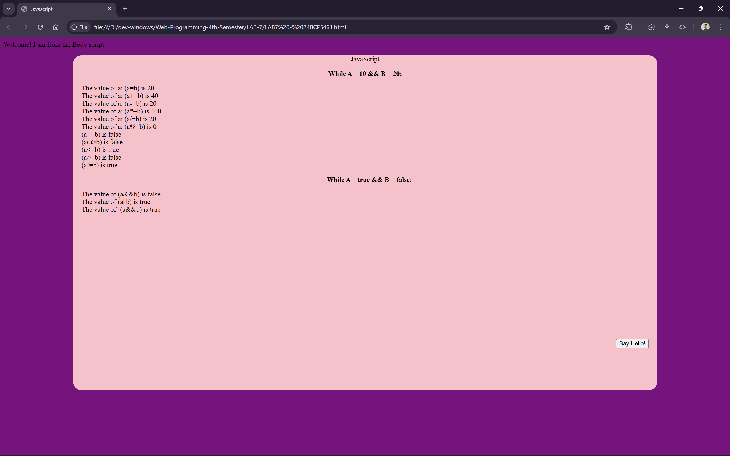

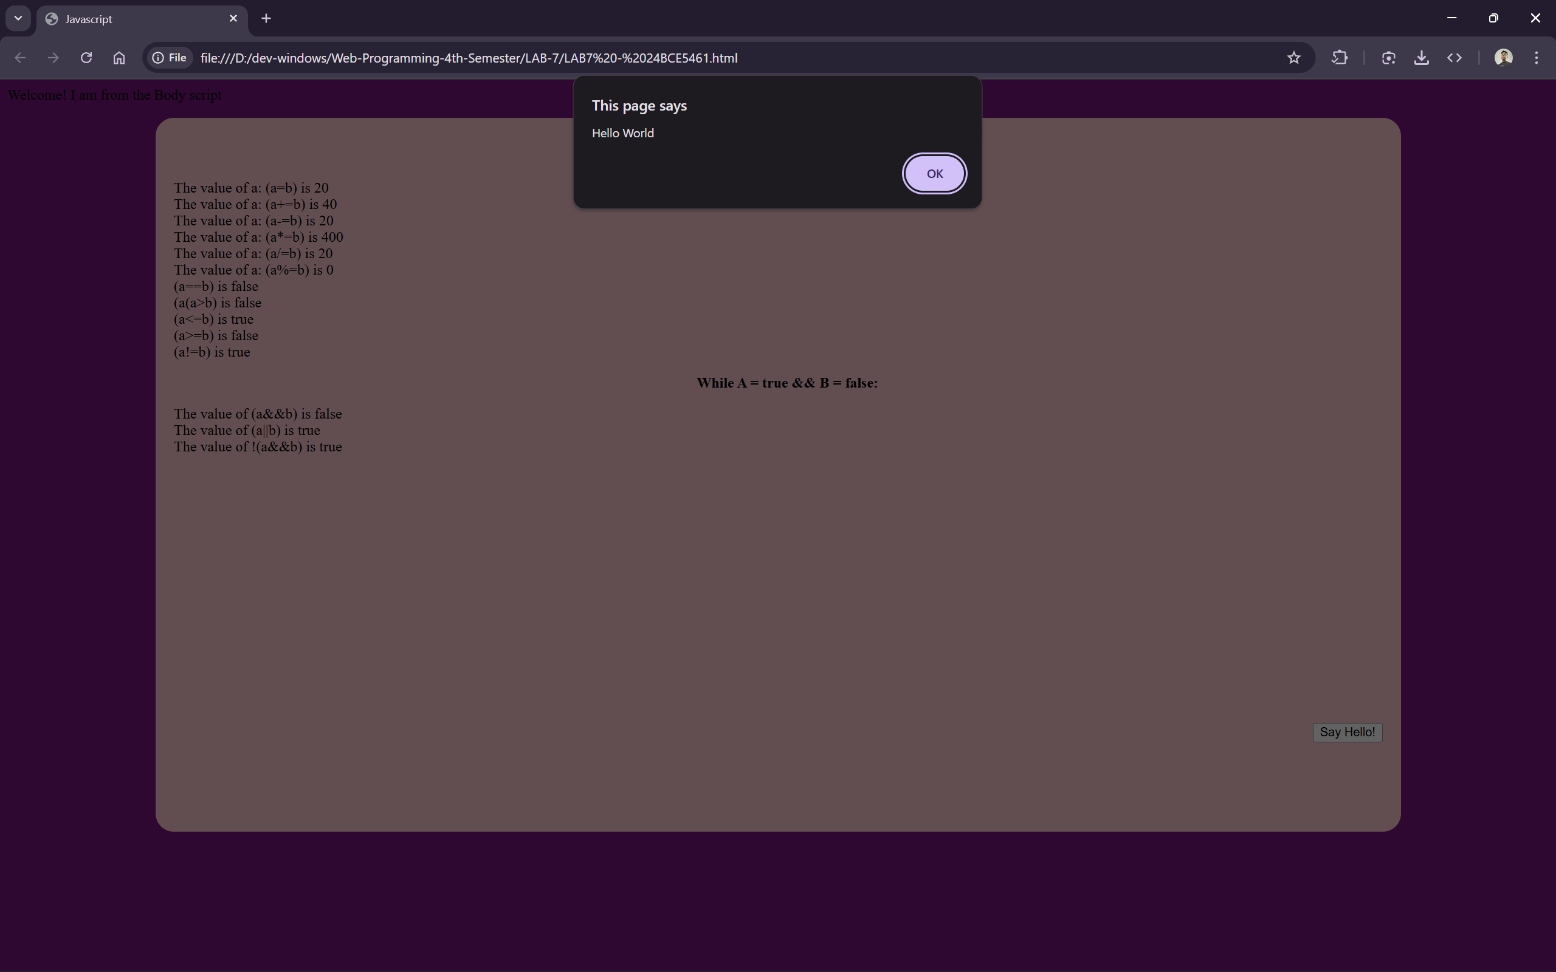

THANK YOU!!!

